1. How can we get this equation? Why G(x(t)) equals to (negative gradient…)

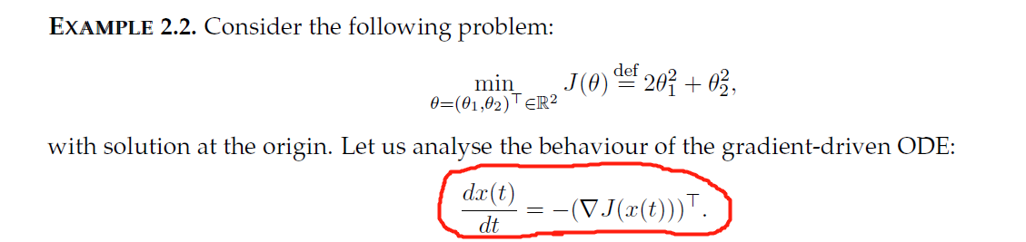

Solved!

1. How can we get the Hessian from the gradient? The Hessian means column vector or row vector? In other words, the Hessian = (θ1,θ2) or (θ1

θ2)

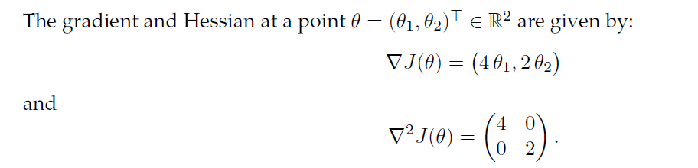

Or if the gradient of θ is as follows, then what is the Hessian of θ ? Could you please show me the steps, I am quite confused.

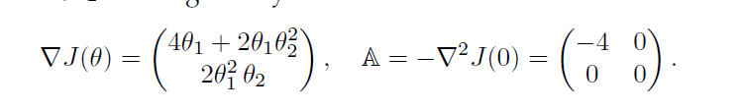

The answer should be (4+2θ1^2 4θ2θ1

4θ1θ2 2θ12)？？or something else.

3.For the interpolation process, I am confused with m(t) function, in my opinion, m(t) should be integer and t could be any real number? Is that right?

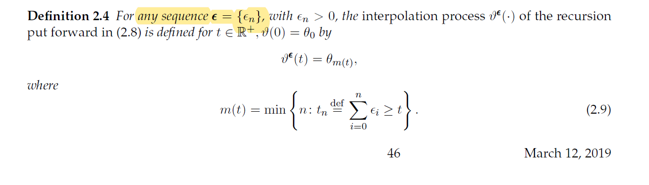

4.How can we get the equation?

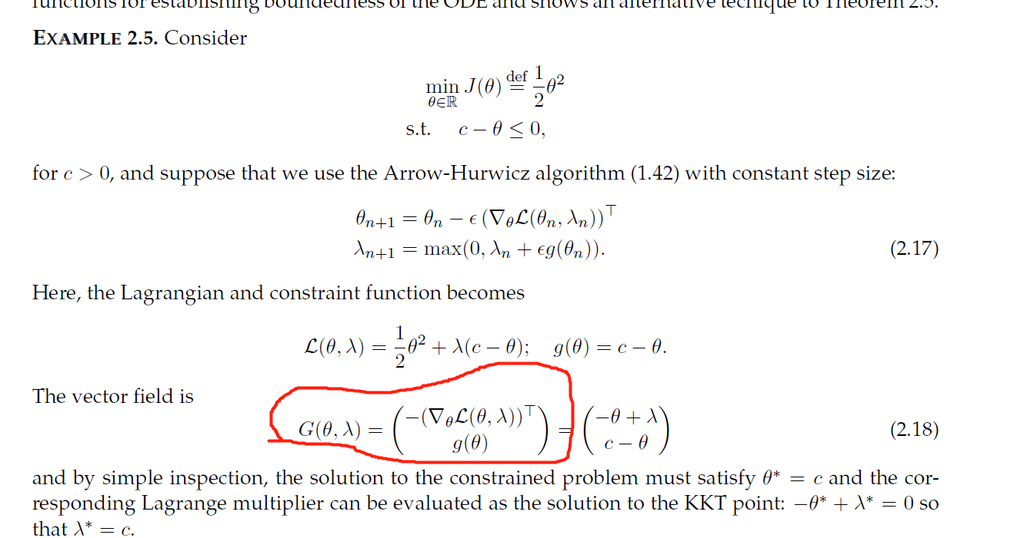

5. I am really confused about how to prove G or X is bounded. What is the theorem to prove if it is bounded.

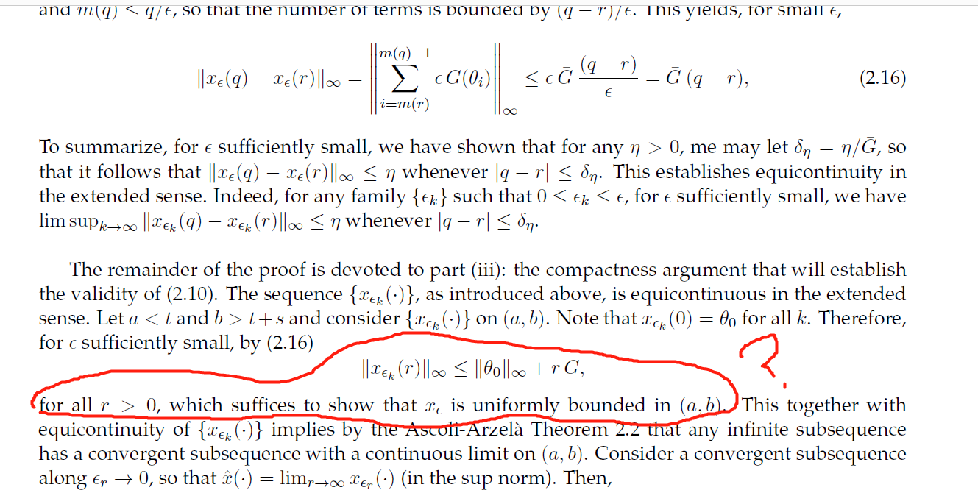

6 What is the differences between Theorem 2.3 and 2.6?

one is constant step size, another is not?

And I am also confused the purpose of these Theorems.

Theorem 2.1 tell us

if T is piecewise continuous and Lipschitz condition, then dx(t)/dt = G, has a unique solution, and x(t) is Lipschitz continuous.

Theorem 2.2 tell us

If a sequence of functions is equicontinuous and bounded, and ||f|| < M, then every sequence has a convergent subsequence, and accumulation points are continuous functions.

Theorem 2.3 tell us

If G is Lipschitz continuous with constant step size e, Xe(t) = v(t), denotes the interpolation process of {θn}, then Xe(t)(0< t <T) converges to the solution of ODE.

Theorem 2.4 tell us

If G is Lipschitz continuous, and has bounded trajectories x(t), with constant step size e, Xe(t) = v(t), then Xe(t) (t>=0) converges to the solution of ODE, and any accumulation point of θ is a asymptotically stable point of G.

Theorem 2.5 tell us

If pk(x) denote real part of eigenvalue of ▽G(x), Hurwtiz condition max(pk(x)) = : -p(max) <=0, then G is bounded along trajectories θ and along the solution x(t) of the ODE.

Theorem 2.6

If G is Lipschitz continuous and bounded, Σe = ∞ ,e -> 0, …, xn(t) = v(tn +t), t>=0, Xn(t) = V(tn + t), t> 0, denote the interpolation process of the shifted sequence {θk}， then as n -> ∞，Xn converges to the solution of ODE.

7. I am also confused about definition 2.6 and 2.7, I don’t know these two definition can solve what kind of questions.